**Report about Website:**

Screenshots of responsive design for page 1 (Home Page)

Bootstrap Carousel at the bottom of the pages, I have used Parallax Scrolling on the first and second bacground images, and no Padding or Margin. I chose the comfortable colors such as blue, orange, white and blak because they are complimentery colours as well as I have considered all types of users such as people with disabilities. I chose the font Arial that is san sherif and safe for web. Moreover, the contrast of text, colour and design has been considered. I tried to make the website more usable responsive and accessable for all types of users.

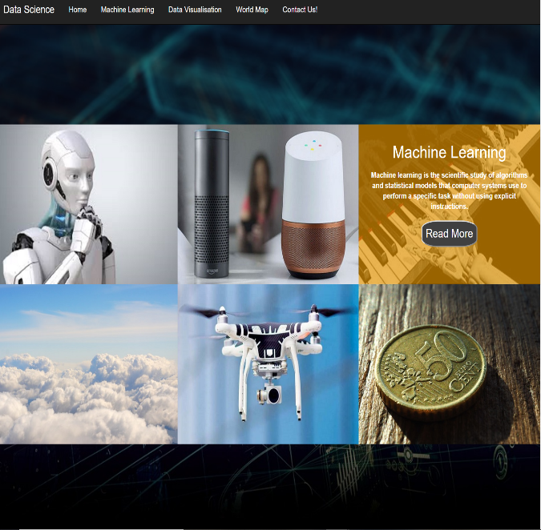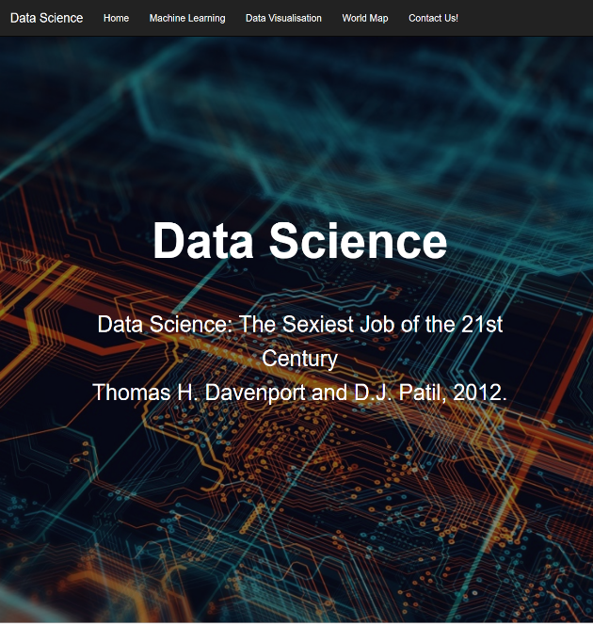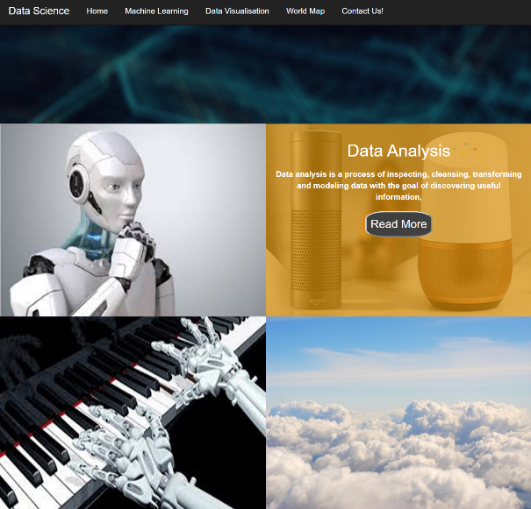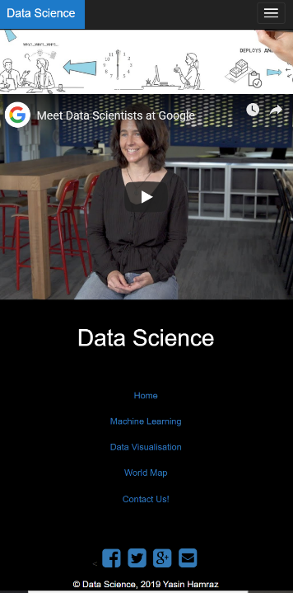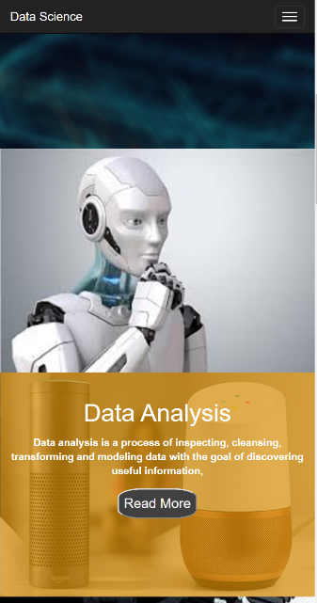

For the figer hover I chose orange and no padding, because the orange makes it more visible and readable for users which two of the 6 images is selected for demonstrating my understanding. The “Read more” links is applied for each block and it takes the visitors to the relevant external website.

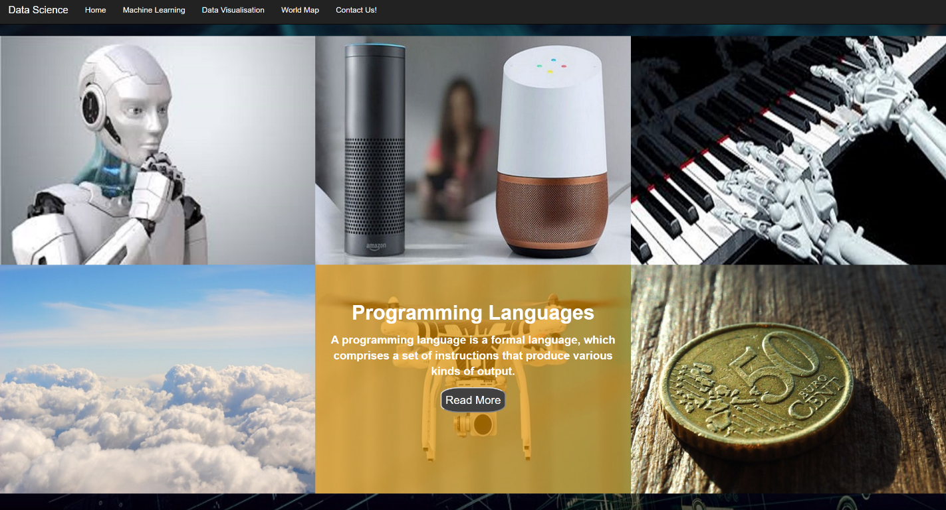

Screenshots of responsive design for page 2 (Machine learning)

For the background image I have chosen the mix colour of blue and black with contrast effect because it is easy as well as more attractive for users. For the title and subtitle I chose the text colour white which that is attractive and readable for everyone.



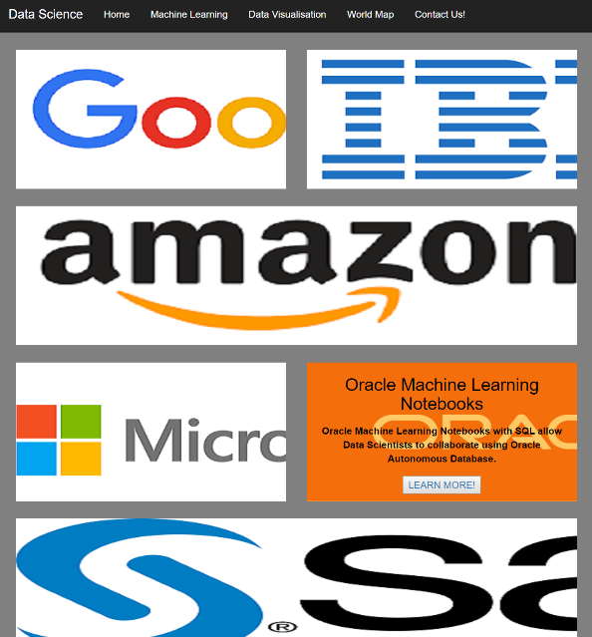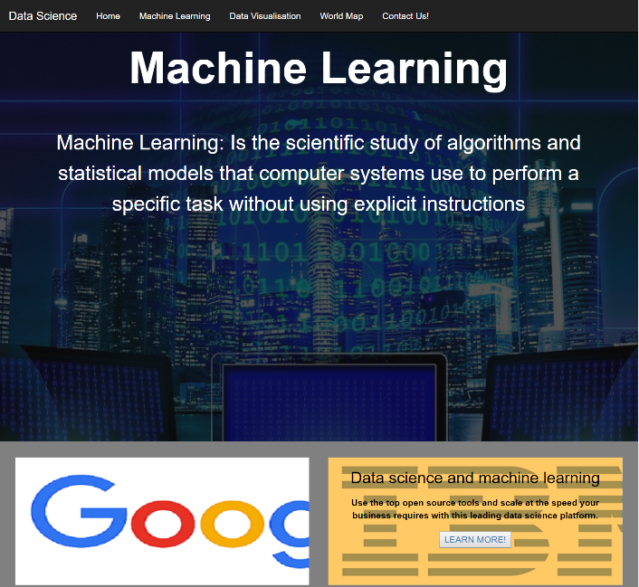

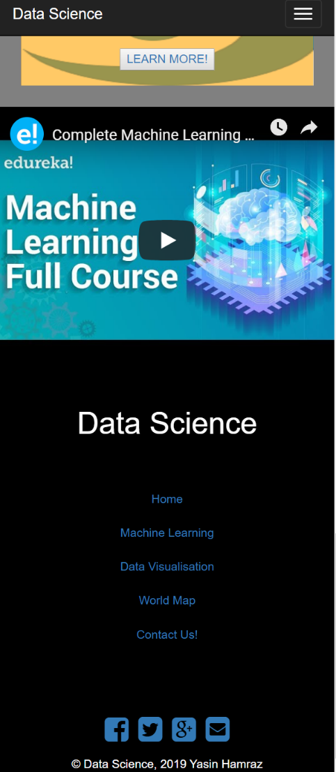

For the images there was no specific way that the assignment asked to have the text so I have added some short information about each company in each block as well as I made it a fig hover caption, to keep the theme from each page through the relevant website. The “LEARN MORE” link takes visitors to the companie’s official web page.

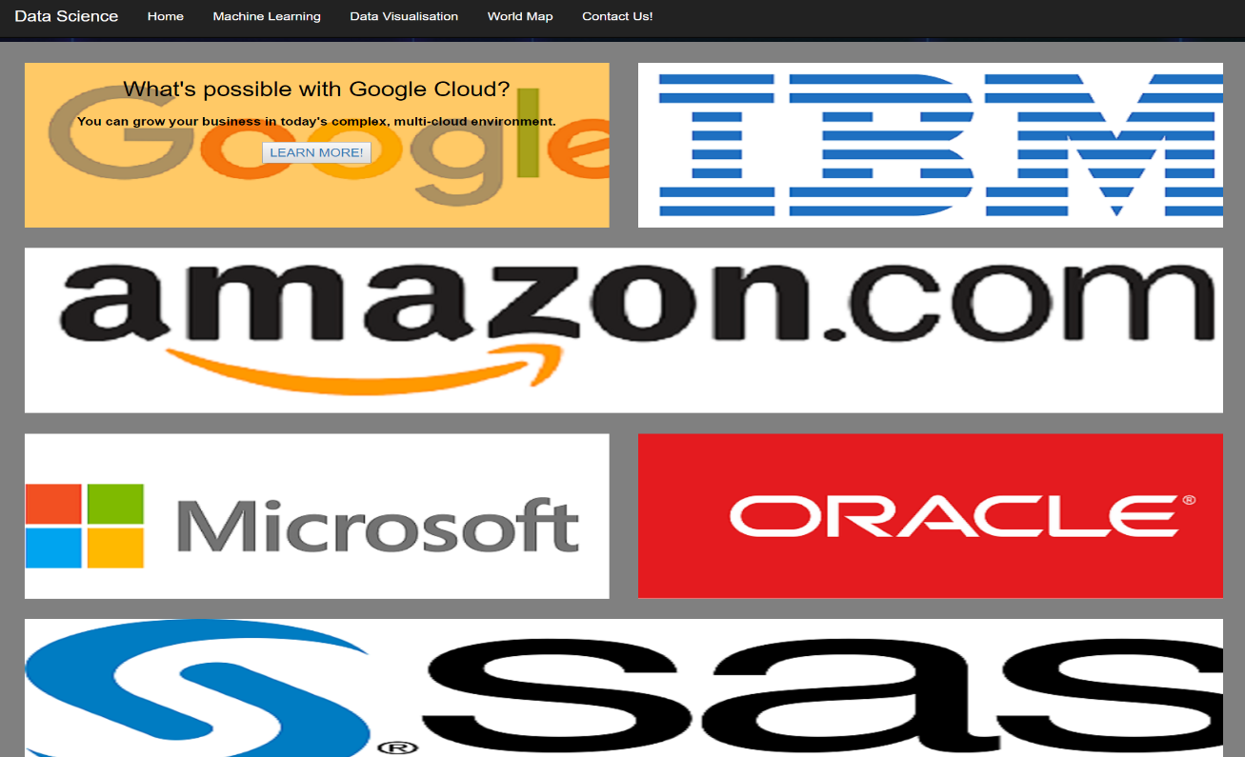

Screenshots of responsive design for page 3 (Data Visualization)

I have the same title and subtitle colour and different background image for the website as page 1 and 2, that way a viwer will see a reoccuring theme on the website, giving the sense of uniformity for the website. For data chart user need to choose the file from project folder “assets/excel file” then chart will be appeared on the screen as screenshot below.

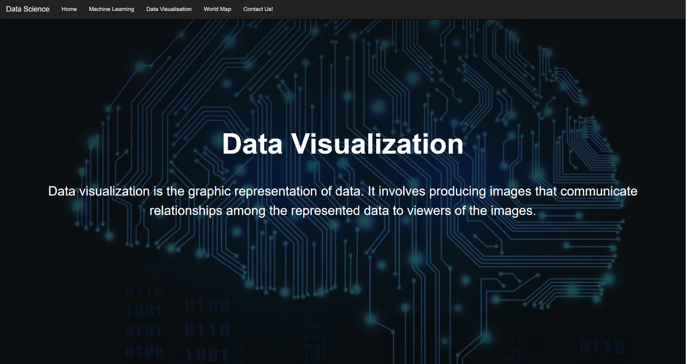

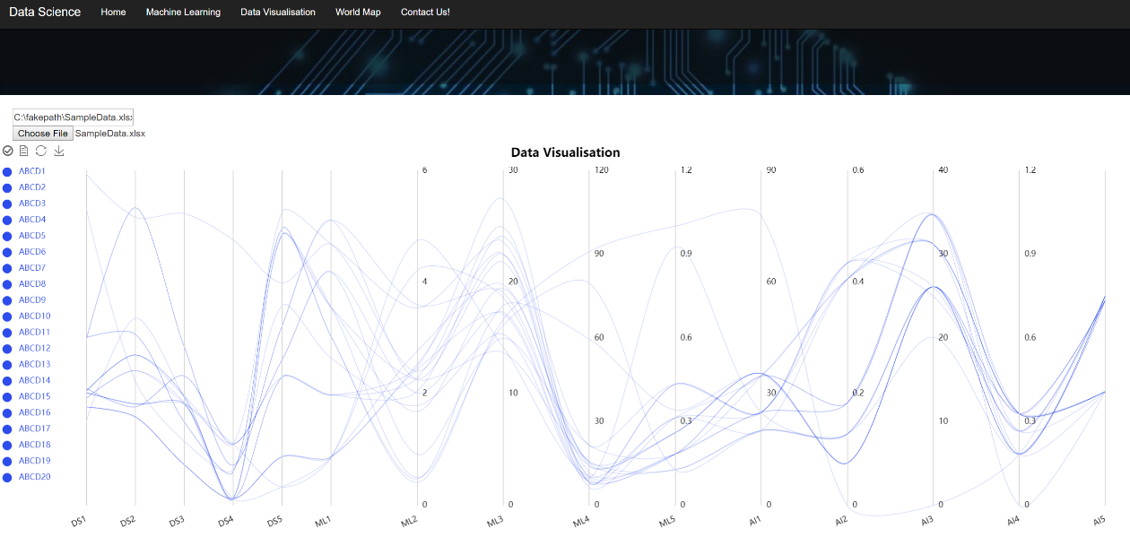

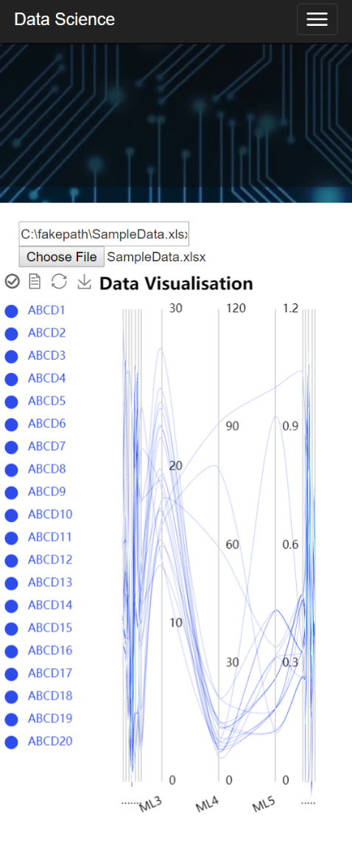

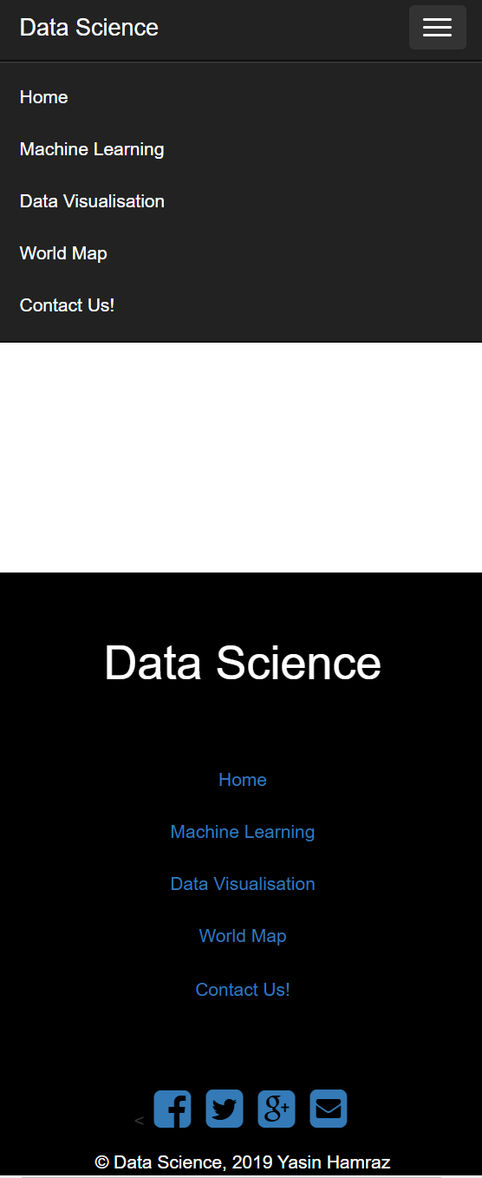

Screenshots of responsive design for page 4 (World Map)

In this page despite background image, title and subtitle 6 Headquarters locations markers for six specific company applied. 2 pairs of markers overlap due to proximity, but they are visible when zoomed in, and other 4 of them are really close together while zoomed will be clearly visible which I have used different colour for 2 of them for more marking convenience.

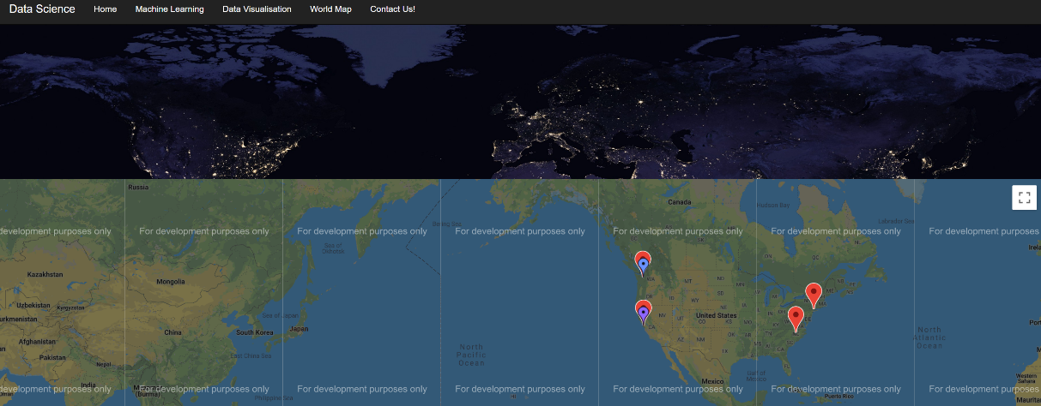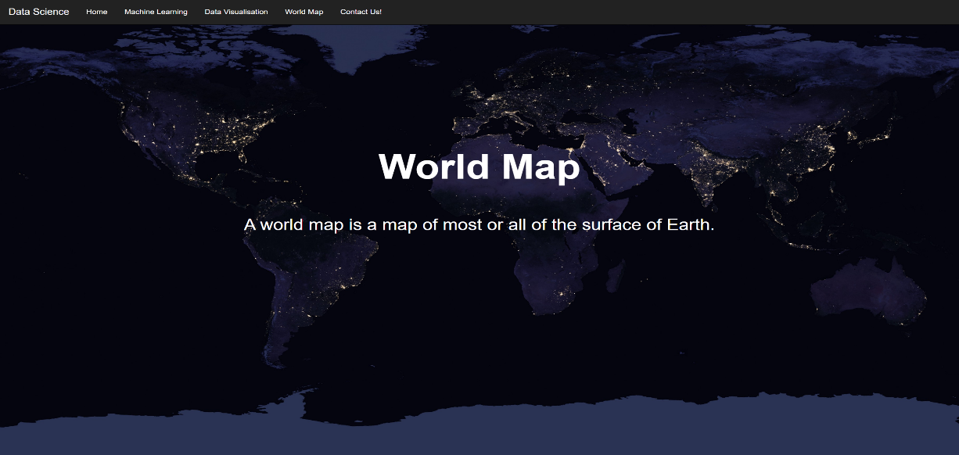

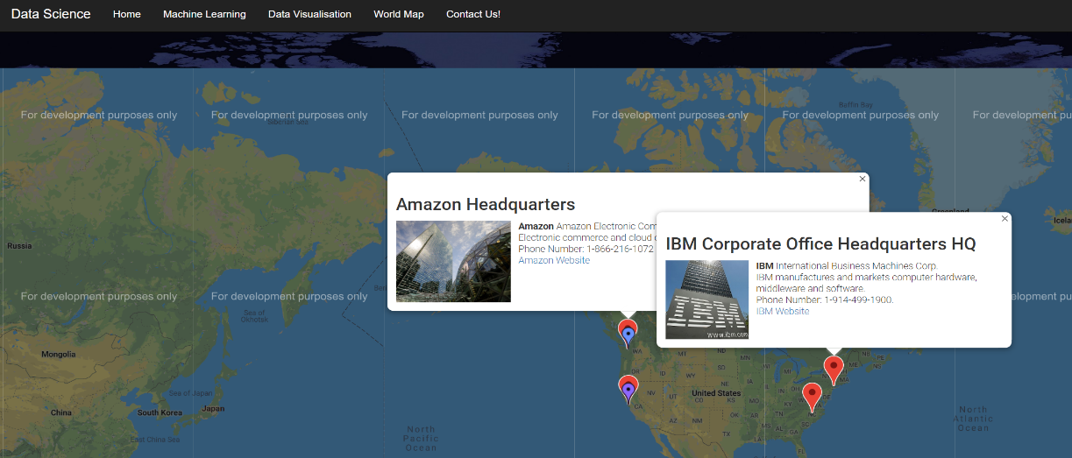

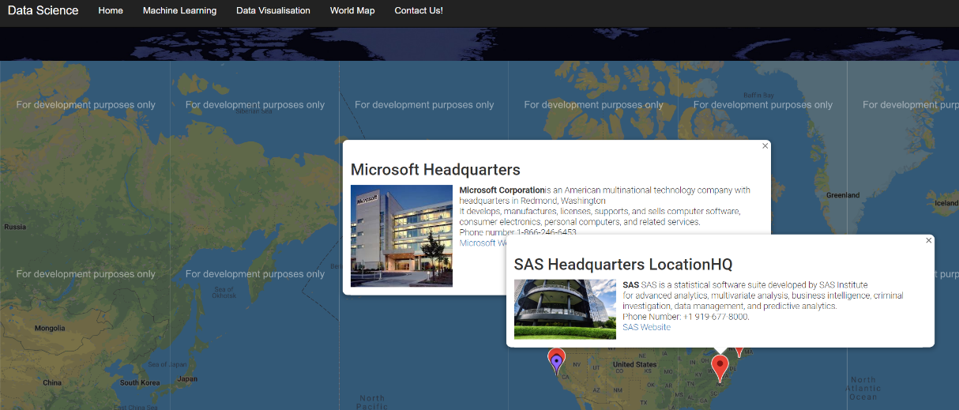

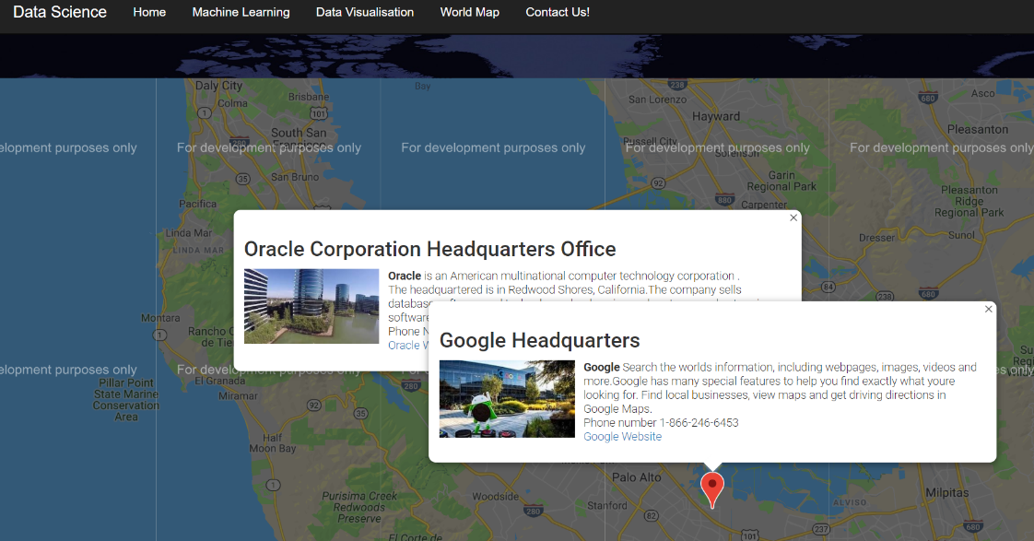

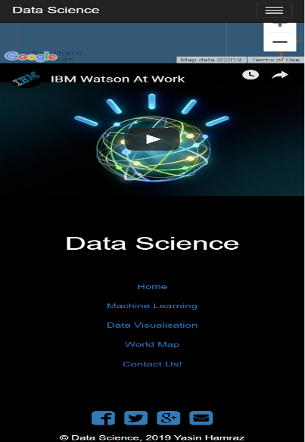When markers are cliked a header, image, and description is shown hypelink also applied.

Screenshots of responsive design for page 5 (Contact page)

The background like call centre and it is paralax on the website. Moreover, I have chosen a related image as background header of the page then two blocks which the first block is for more details about website such as About Us, Contact Us and Feedback and the second bloc is relevant video to contact page.

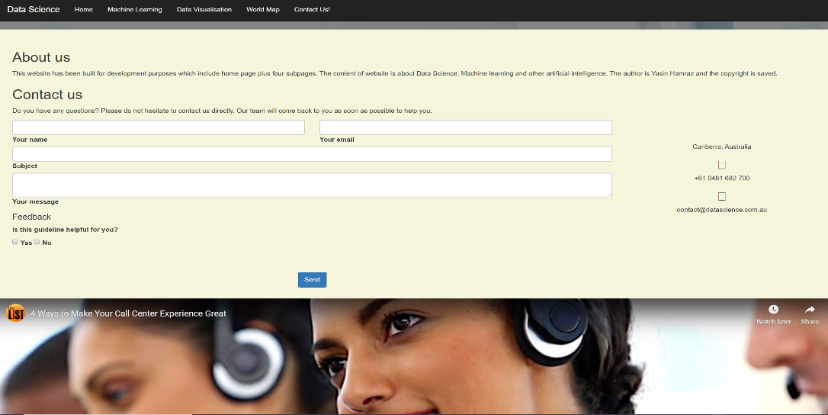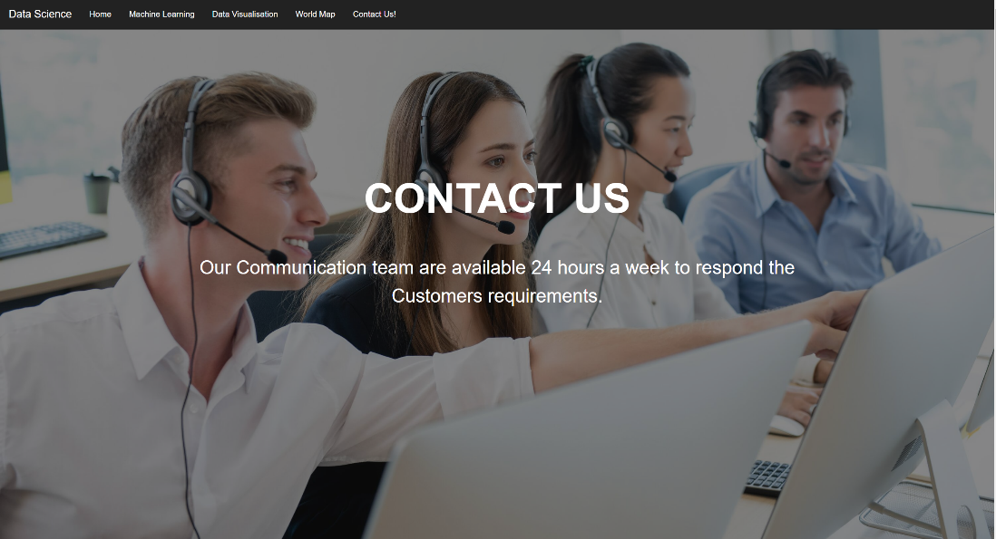

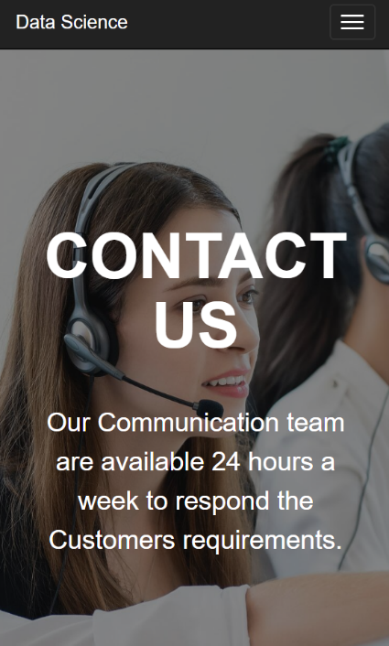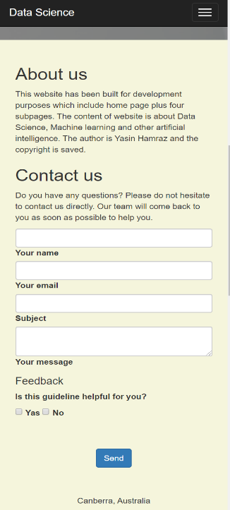

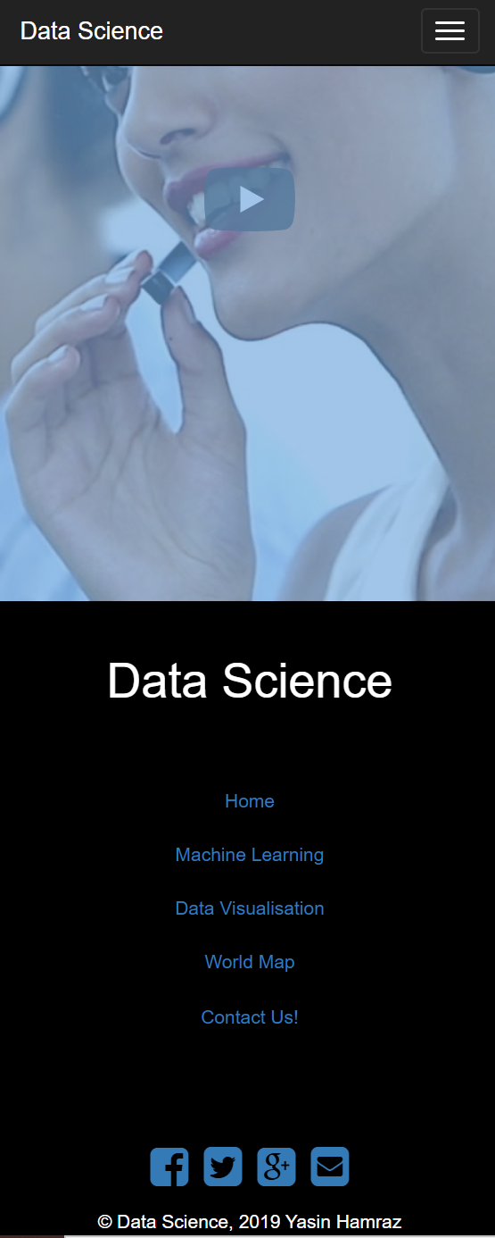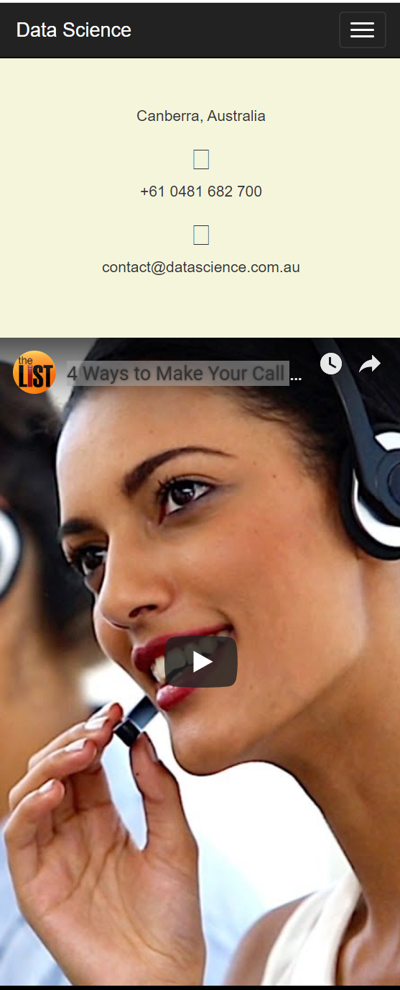

**References**

The text and images are used in my website sourced from the following links:

<https://www.ibm.com/ibm/us/en/?lnk=fab>

<https://www.industry.gov.au/topic/about-us>

<https://www.w3schools.com/jsref/event_onclick.asp>

<https://www.headland.com.au/industry-4-0-cheat-sheet-industry4-0-cloud-computing-smart-factory-internet-of-things/>

<https://www.microsoft.com/en-us/ai?activetab=pivot1%3aprimaryr5>

<https://www.ibm.com/au-en/industries/manufacturing>

<https://towardsdatascience.com/role-of-data-science-in-artificial-intelligence-950efedd2579>

<https://elitedatascience.com/learn-statistics-for-data-science>

<https://www.edx.org/course/machine-learning-data-science-analytics-1>

<https://medium.com/datadriveninvestor/top-6-data-science-programming-languages-for-2019-39ba1b6819a8>

<https://towardsdatascience.com/tagged/data-analysis>

<https://towardsdatascience.com/data-visualization/home>

<https://www.youtube.com/watch?v=X3paOmcrTjQ>

<https://www.youtube.com/watch?v=0jQ25PSyb_E>

<https://www.ibm.com/au-en/analytics/machine-learning>

<https://aws.amazon.com/machine-learning/>

<https://cloud.google.com/products/ai/>

<https://azure.microsoft.com/en-au/services/machine-learning-service/>

<https://www.oracle.com/database/technologies/datawarehouse-bigdata/oml-notebooks.html>

<https://www.sas.com/en_us/software/visual-data-mining-machine-learning.html>

<https://www.youtube.com/watch?v=UzxYlbK2c7E>

<https://www.youtube.com/watch?v=8o44asJt8ZA>

<https://www.einfochips.com/contact-us/>

<https://www.industry.gov.au/topic/about-us>

<https://www.w3schools.com/bootstrap/bootstrap_navbar.asp>

<https://mdbootstrap.com/docs/jquery/forms/contact/>

<https://developer.android.com/index.html>

<https://getbootstrap.com/docs/4.3/utilities/flex/>

<https://www.w3.org/TR/2016/REC-html51-20161101/dom.html#elements-semantics>

<https://meyerweb.com/eric/tools/css/reset/>